IB DP Geography - Patterns & Trends in land/food, including changing diets
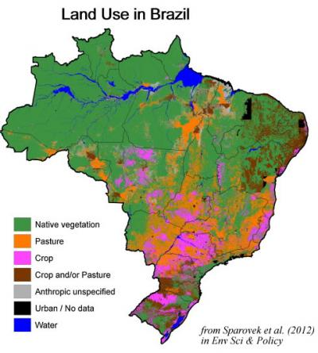
Starter: Comment on the availability of land in Brazil for agricultural purposes and explain the link between the exploitation of the land for food consumption and climate change.

In the space below, ‘thought shower’ as many reasons as possible why people may eat more unhealthily as level of economic development increases.

Task 1 - Watch the first video that is based on a presentation on a world famous photography project by Peter Menzel that documented the weekly eating habits of different families around the world.

Make notes on his overall observations:

- General food shopping habits around the world

- The problems caused by intake of too many calories (obesity) in the USA.

- Impact of food globalization on the tribes in Papua New Guinea

- Transition of China into a meat diet as well as regional disparities within the country

- What the 80% rule means in Japan.

Remember!
Food intake (measured by calorie intake) has gone up dramatically in most regions of the world. This has been due to our ability to increase crop production in the following ways:

1. Expanding the areas that we farm (clearing rainforest for pasture for cattle grazing)
2. Better use of irrigation (potatoes being grown in Egyptian desert)
​3. Using HYVs and the use of GM crops (drought resistant corn)

There have been major changes in diets moving away from traditional home grown and seasonal produce to a more varied diet containing dairy products, meat and of course fast food. This transition has come about with rapid urbanisation, more people working for longer hours, competitive pricing and aggressive marketing campaigns by TNC's in LICs and MICs.

Focus on Brazil – Changing Diets
Using the information from the video and the New York Times article on ibgeographypods.org, complete the grid below with notes based on the 4P’s format.

Process | Place
Power | Possibility

IB DP Geography – Exam Revision
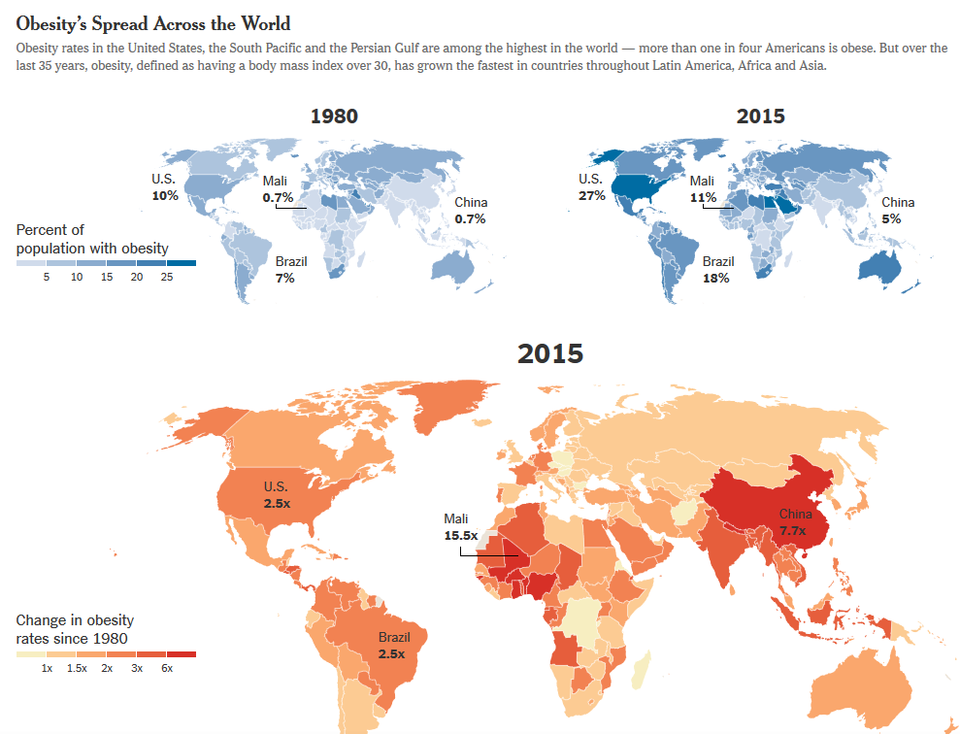

Describe and explain the patterns and trends in changing diets on a global scale between 1980 and 2015 (2+2+2)

