IB DP Geography – Responding to Climate Change – Lesson 1

Turn to page 451 – 452 of the Geography guide and complete the activities beneath.

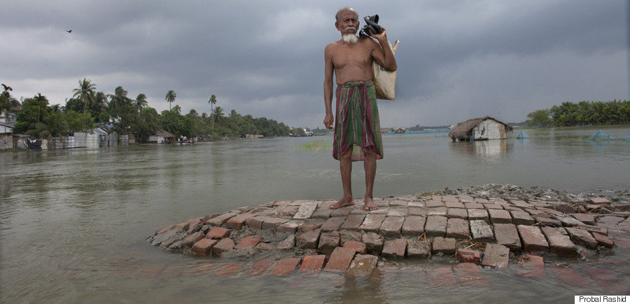

Task 1 - Annotate the picture above with factors that affect the susceptibility of vulnerable populations.

Task 2 - What does vulnerability refer to?

Task 3 – Outline the three main factors associated with vulnerability below.

Task 4 – Using the text, outline who the more vulnerable populations within society may be. Try to explain at least two of these in more detail in the space beneath.

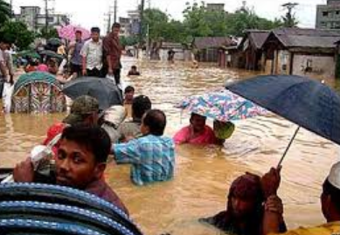

Task 5 – Annotate the map below with the names of the vulnerable nations and potential impacts of sea level rise on those places.

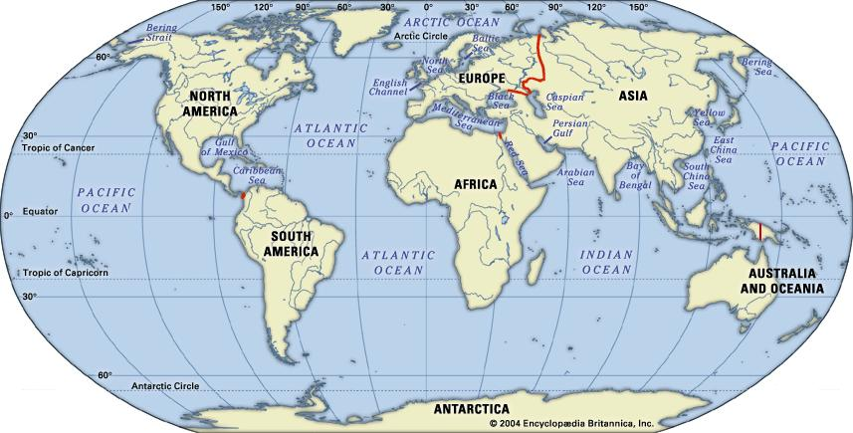

Task 6 – Outline briefly the five issues affecting the places above.
1
2
3
4
5

Climate Change – Impacts on Swiss Ski Resorts
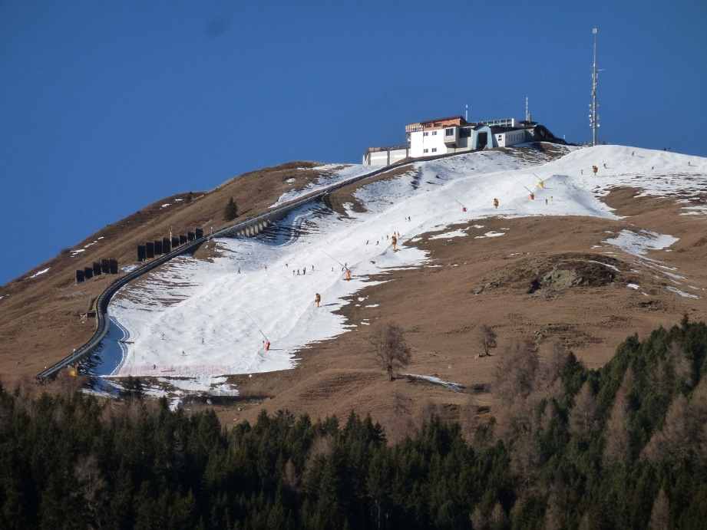
Figure 1 - Source, Carbon Brief.
Task 7 - https://theweek.com/news/sport/959422/climate-change-alps-end-of-skiing - Outline the how bad the problem of a lack of snow is from the first paragraph, including 5 pieces of key data.

Task 8 - Outline how the ski resorts are trying deal with the problem.

Task 9 – How bad might it get for Swiss ski resorts in the future? Reference the issue below 1500 metres too.

Task 10 – To what extent will this impact on winter sports enthusiasts in the future?

Task 11 – Using the two charts below, describe the trends shown, making reference to key data.
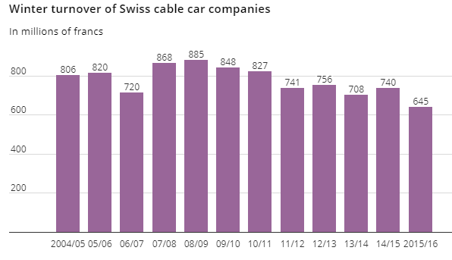
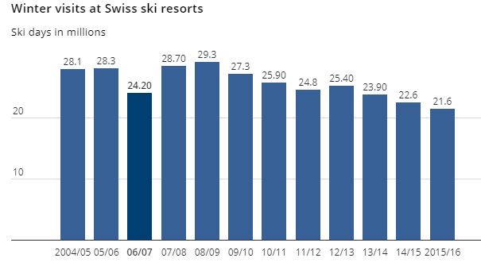

Task 12 – To what extent do the graphs above justify future tourism developments for the summer season?

Task 13 - Impacts on the Nunavummiut – Northern Canada
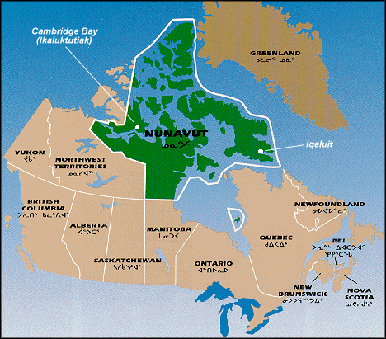
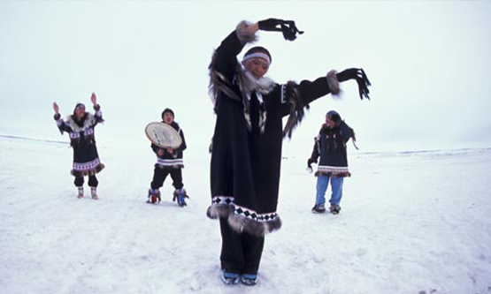
Impacts on Transportation
Use this link to complete activities: https://www.climatechangenunavut.ca/en/understanding-climate-change/climate-change-impact

Impacts on Heritage and Special Places
Impacts on Health and Diseases
Impacts on Traditional Activities
Impacts on cultural identity
Impacts on Food Security

