IB DP Geography - The Diffusion of Cultural Traits
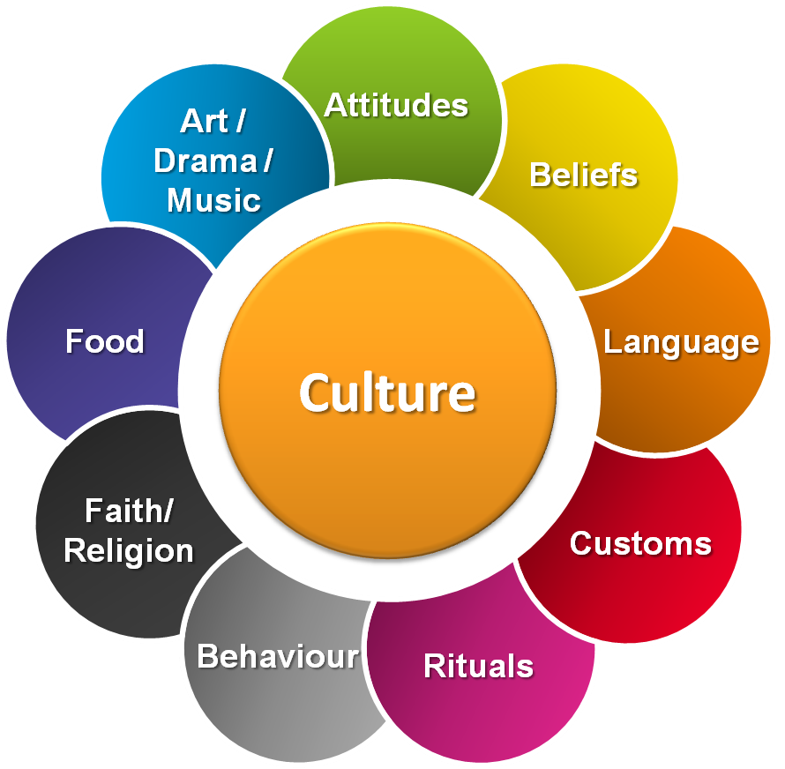

What is culture?
​Culture is our way of life. It includes our values, beliefs, customs, languages and traditions. Culture is reflected in our history, in our heritage and in how we express ideas and creativity.

Our culture measures our quality of life, our vitality and the health of our society. Through our culture we develop a sense of belonging, personal and cognitive growth and the ability to empathize and relate to each other.

Direct benefits of a strong and vibrant culture include health and wellness, self esteem, skills development, social capital and economic return. Culture is constantly shifting too and should be seen as dynamic and not fixed. (Source)

Cultural diffusion is the spread of cultural beliefs and social activities from one group of people to another.

This involved the mixing of world cultures through different ethnicities, religions, and nationalities has only increased with:

* advanced communication
* transportation
​* technology.

Task 1 – Describe your culture

Task 2 – Describe a culture that you have experience that was vastly different from you own.

Is there such a thing as a developing 'Global Culture'?

​As the planet becomes more and more connected, people and financial flows increase between places, it has been suggested that the spreading of cultural traits (westernization) and mixing of cultures (hybridity) may be leading to a new universal cultural practice.

Task 3 - Read the article from Forbes on ibgeographypods and highlight the main ways in which Balaji Viswanathan disagrees with a global culture being created.

