IB DP Geography – Demographic Transition
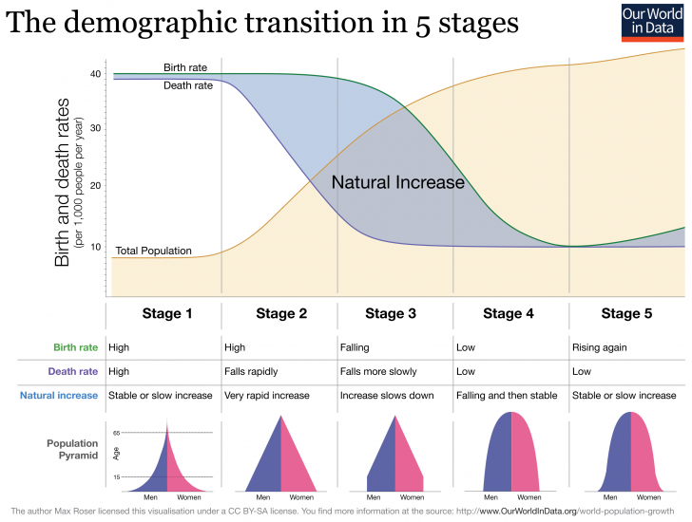

 | Describe life in this a country at this stage of the DTM | e.g. place in the World
Stage 1  High fluctuating | Birth rates and death rates are high in this country. Lack of contraception, lack of female empowerment and low literacy rates lead to high fertility rates. Infant and child mortality is high and caused by a lack of post-natal healthcare and this lack of basic medical care leads to a very low life expectancy due to HIV, AIDS, cholera and other diseases. Despite both birth & death rates being high, they almost cancel each other out leading to a small natural increase. The population structure (pyramid) has a wide base (high birth rates) a concave side (high mortality rates) and a narrow peak (low life expectancy). LIC rating GNI per capital <$1000 | No country is left in this stage any longer. Remote tribes in the Amazonian rainforest or in Borneo may still fit the characteristics in this stage.
Stage 2
Early expanding
Stage 3
Late expanding
Stage 4
Low fluctuating
Stage 5
Natural decrease / small increase

