Government & Militia Controls over Global Interactions – Eritrea.
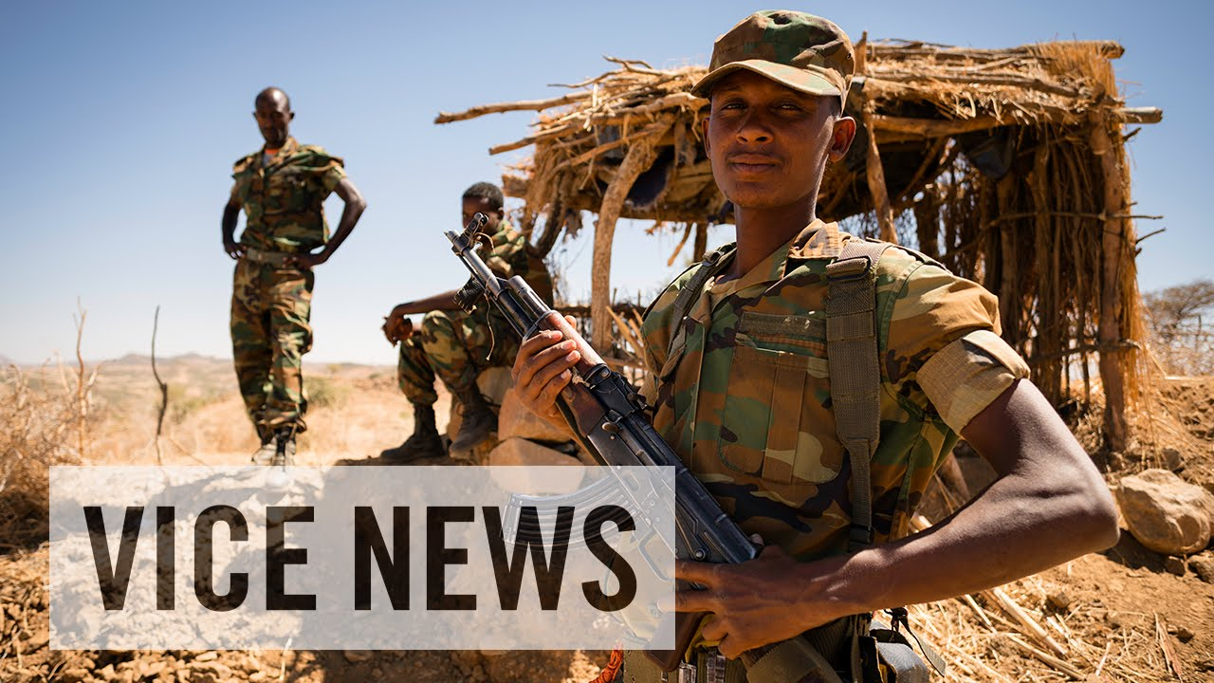

Task: Watch the Vice Video embedded on the site and make notes on the different restrictions that you see taking place in Eritrea.
Place | Power
Process | Possibility

