|  |
| --- |
| **IB DP Geography – Overview & Links** |

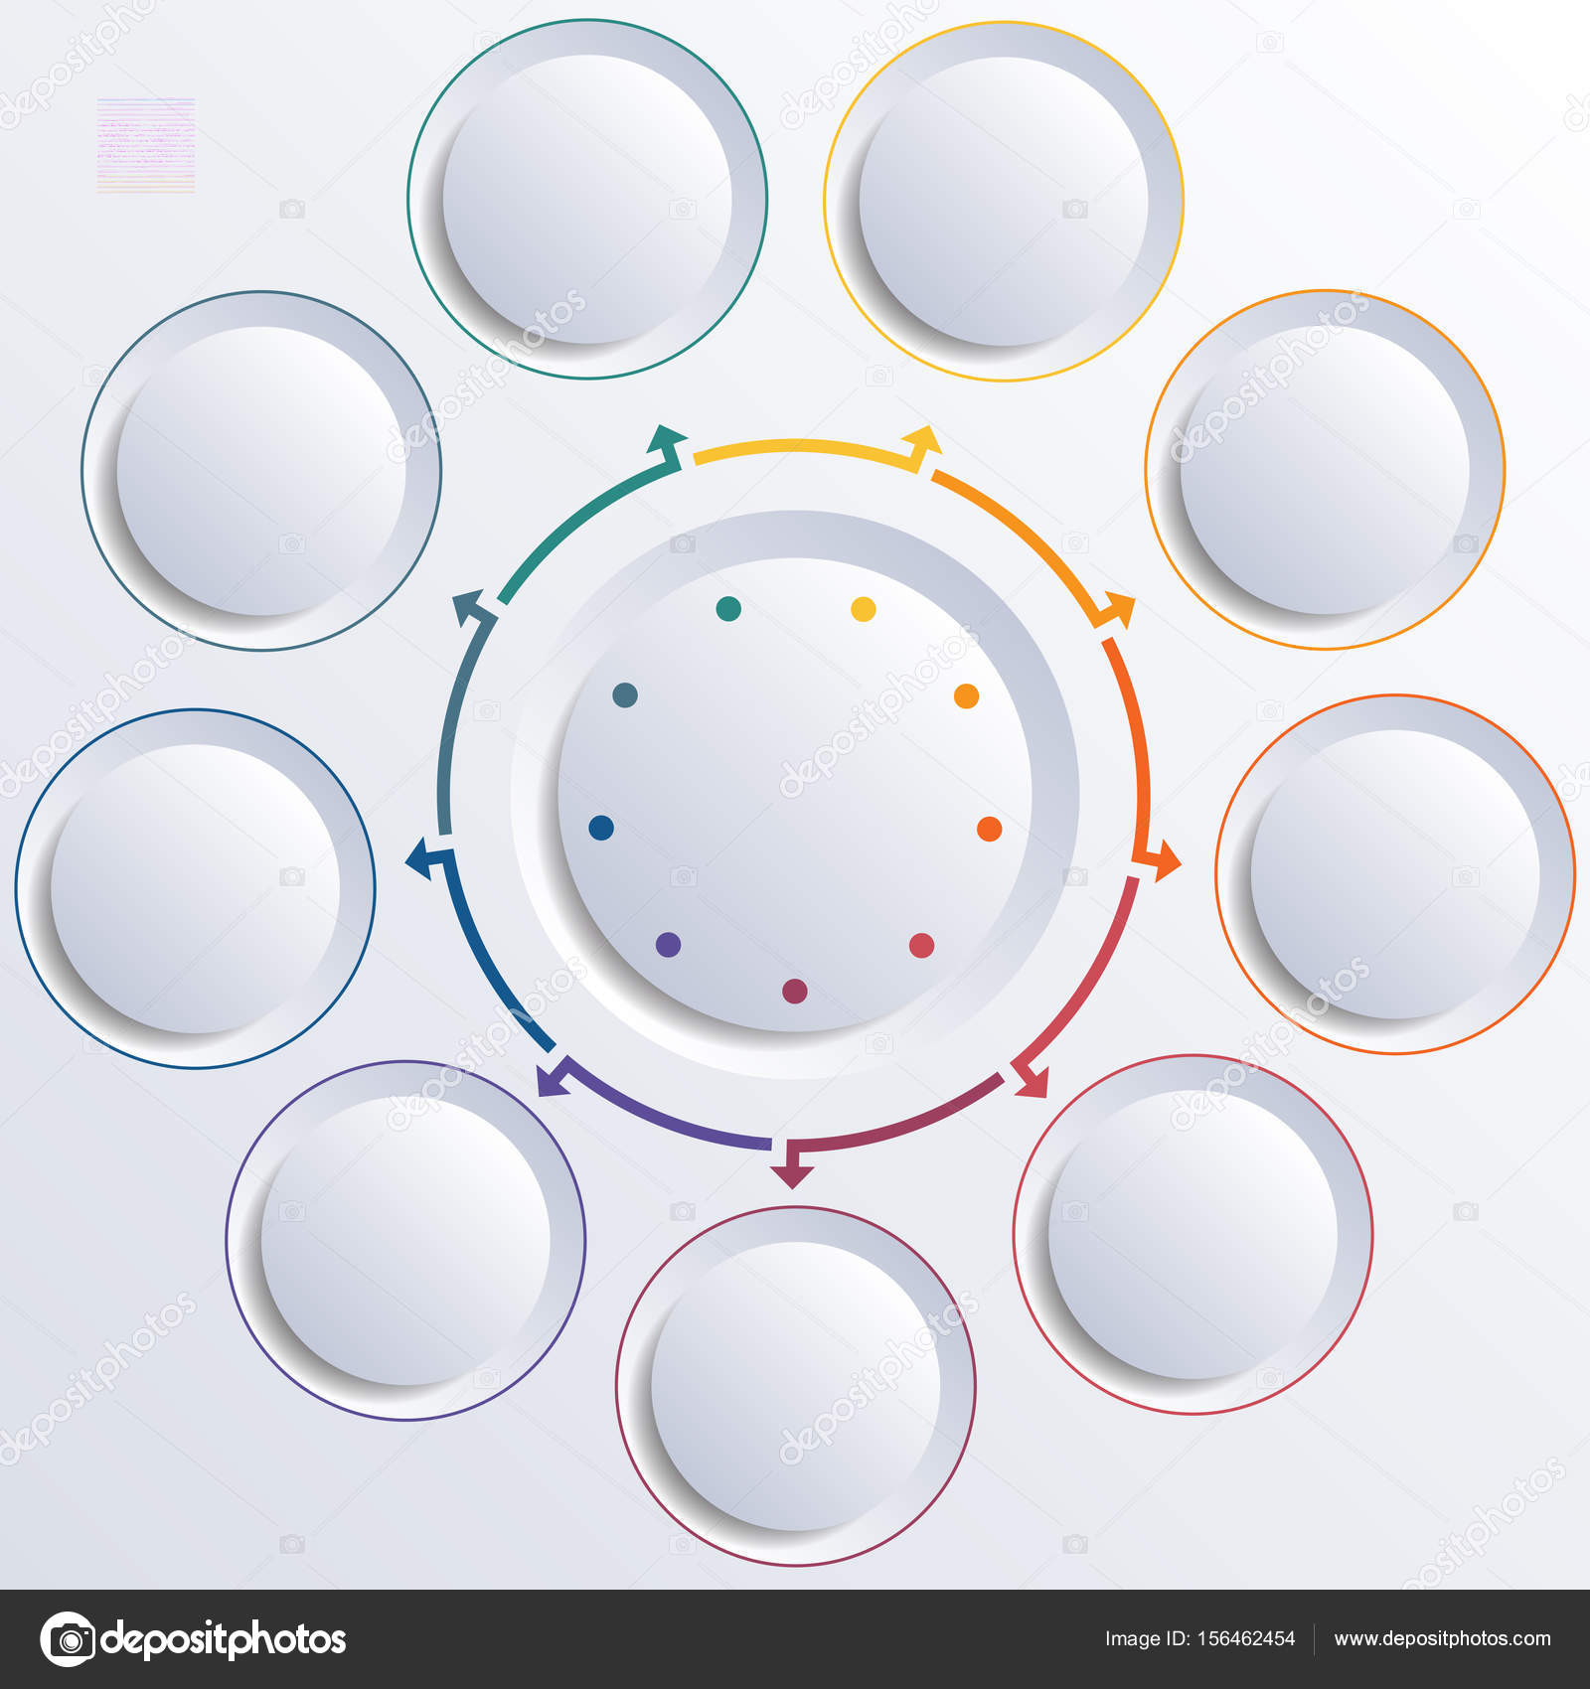

Notes