Population distribution – HIC / LIC Comparison
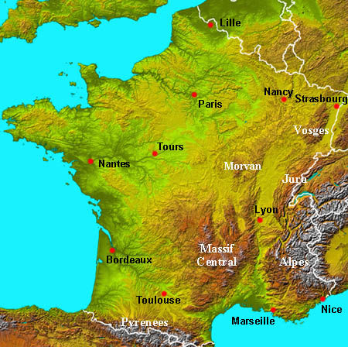
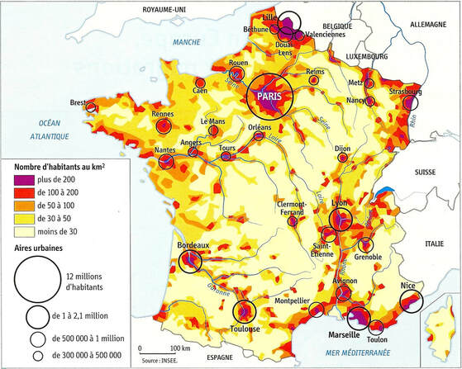
France

Define population distribution and then describe the population distribution of France and explain the reasons behind this pattern.
Population distribution is…

Ethiopia – There are larger versions of the maps below on ibgeographypods.
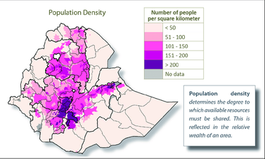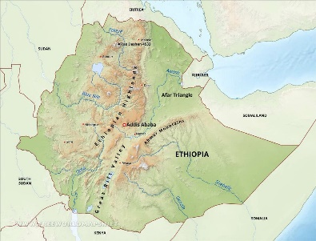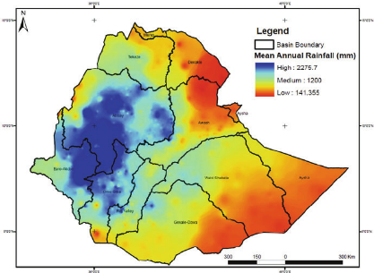

Describe the population distribution of Ethiopia and explain the reasons behind this pattern.

Internal Migration – HIC / LIC Comparison
France
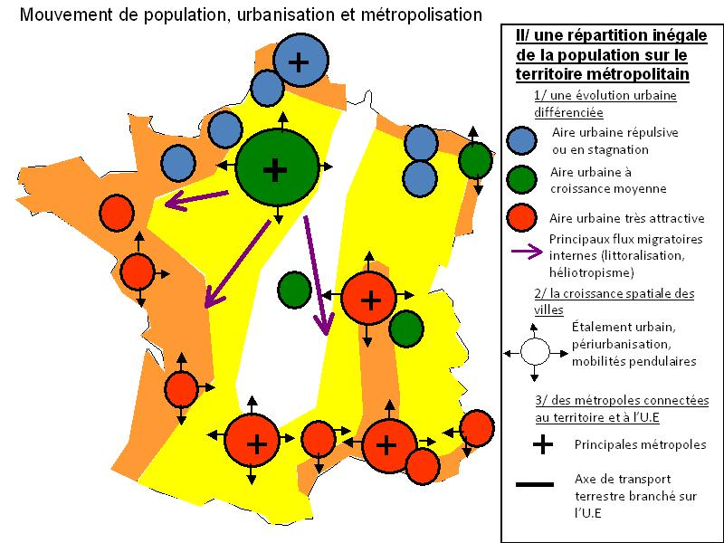
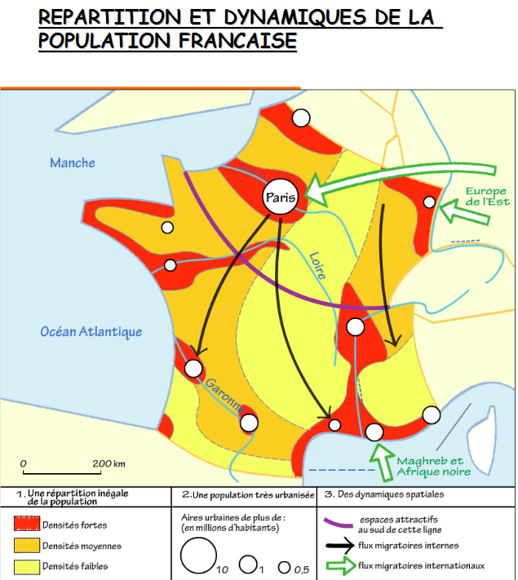

Describe the patterns of internal migration in France and explain the reasons behind these patterns.

Ethiopia
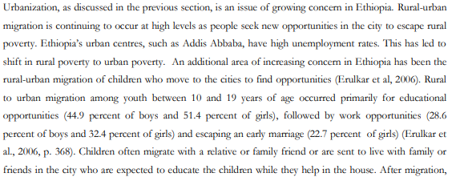

Highlight in the text above the key reasons why people migrate internally in Ethiopia. Why is life difficult in many rural areas in Ethiopia and why does this push them to cities?

Using the resources on the previous two pages, explain the core and periphery of both France & Ethiopia and how this links to human and physical factors.

Stop check!
Define migration
Define internal migration

Internal migration can be characterised by both push and pull factors. Name at least 8 in each column and then colour code to show 1. Economic 2. Cultural 3. Environmental
Push Factors  “Events and conditions that compel an individual to move from a location” | Pull Factors  “Are conditions that influence migrants to move to a particular location”

