IBDP Geography – Global Interactions &
Transport Developments over Time

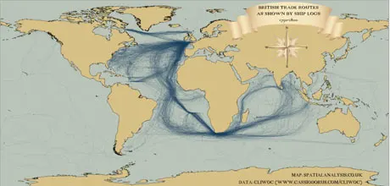

Above - 18th Century British shipping routes visualised using modern mapping technologies. Comment on the patterns of shipping in the 18th century.

Why did these routes exist and what was being transported?

Watch this YouTube video that visualises all shipping routes between 1750 – 1850. Comment on the pattern of travel, referring to Spain and Holland.

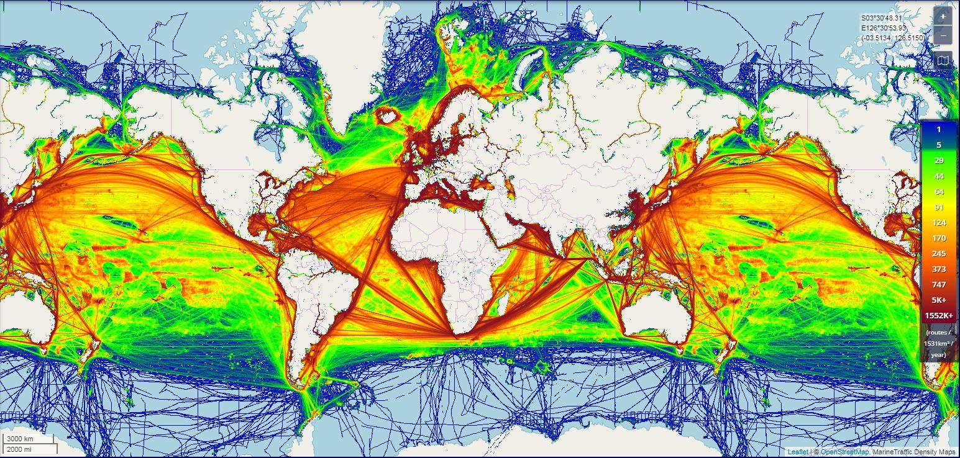

Study the map above that shows the modern-day routes of marine traffic. Comment on the changes that are now evident on this map and the old routes shown on the YouTube video.

Improvement 1 – Getting more for less – The invention of the container!

Most of our stuff gets to us on ships. Most of those ships transport our goods in containers. You will have seen containers before on the back of lorries and wagons as they make their way to the final distribution centres. However, containers haven’t always been around. Watch this mini documentary to find out more about the so-called godfather of modern-day shipping. Take notes.
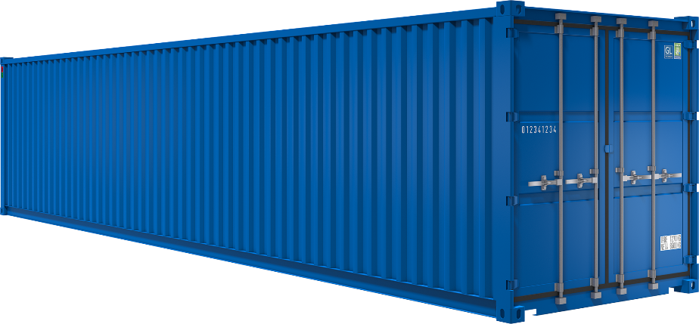

Improvement 2 – Cutting journey time - The Panama Canal

Shipping routes. You are going to conduct a short piece of research on the Panama Canal. Watch this video and make notes on how this man-made project has revolutionised shipping between the Atlantic & Pacific oceans. Take notes.
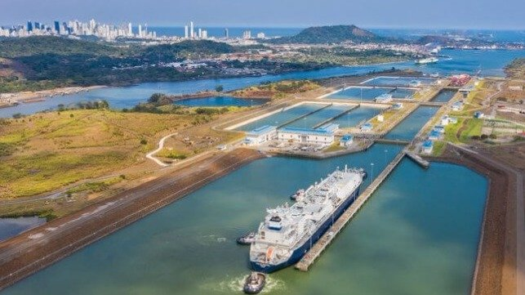

Describe and explain the changes in speed and capacity in transport over time (12)

- Speed – Panama Canal
- Capacity – Containers
- Focus – Container Ships

Introduction

Main body 1

Main body 2

Conclusion

