IB DP Geography – Introduction to Atmosphere

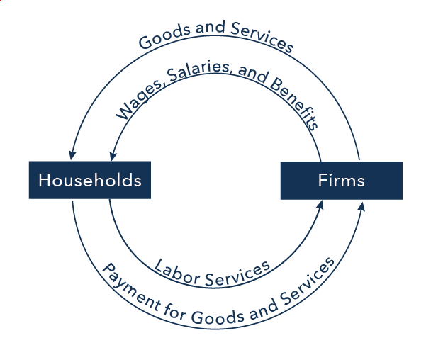

In the diagram, firms produce goods and services, which they sell to households in return for payments. The outer ring represents the two sides of the product market (which provides goods and services), in which households demand and firms supply. In addition, households (as workers) sell their labor to firms in return for wages, salaries, and benefits. This is shown in the inner circle, which represents the two sides of the labor market, in which households supply and firms demand. (source)

