IB Geography - Globalization – A Perfect Example? … & Twitter
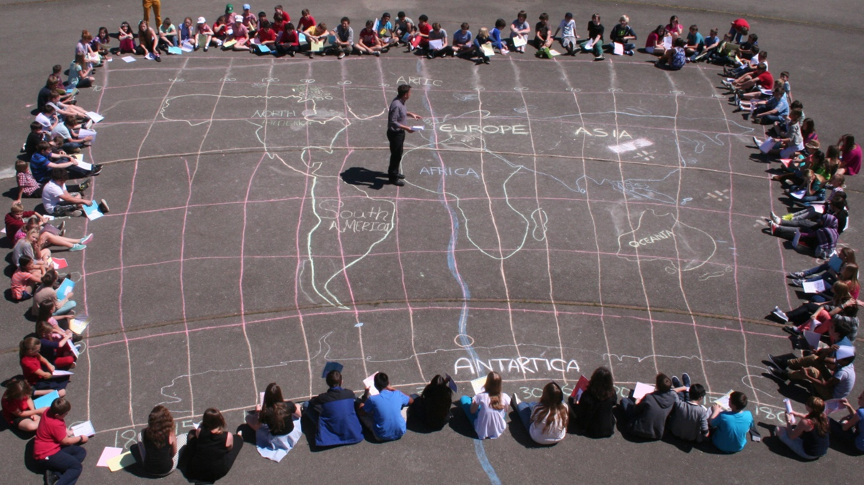
"Globalization is the growing interdependence of countries worldwide through an increasing volume and variety of cross-border transactions in goods and services and of international capital flows, and through the more widespread diffusion of technology"
Task 1 – Can you think of the perfect product of service that encapsulates each element of the definition above?

countries become interdependent  Product or service image here | increasing what they buy and sell with each other
resulting in the flow of money (capital) between places | and the sharing and take up of technology in those countries

Task 2 – Say hello to the IB Students. Shade in on the map the locations of where your hello Tweets come from in the world.

Screenshot of Tweet here (including number of likes, responses and analytics) – You will receive this from your teacher.

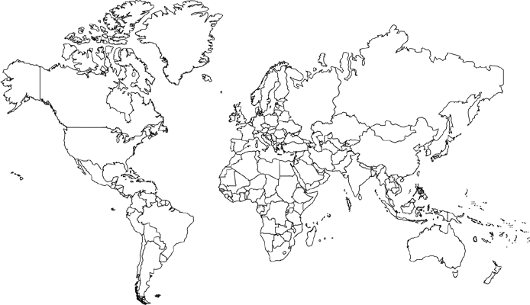

Shade in countries that replied to our tweet above.

