IB DP Geography – Rise of the Middle Class
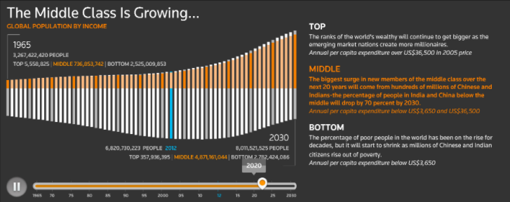

Task 1 – Using the information in the image above, describe & explain the reasons for the trend on the graph.

2020 – Projected % of population (middle class)
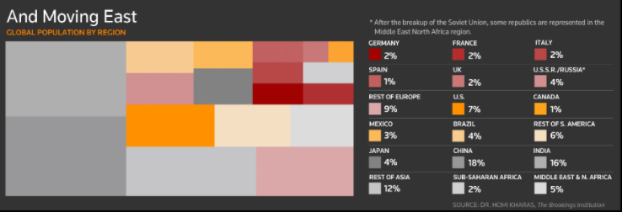

2030 – Projected % of population (middle class)
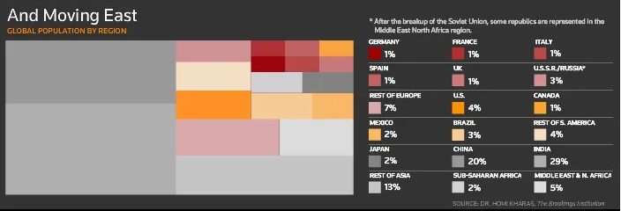

Task 2 - Using the images above, plot the % change in the middle classes between 1970 – 2030 (projected). Shade in green for increase and red for reduction.
Year | FRANCE | USA | CHINA | INDIA
2020 est
2030 est

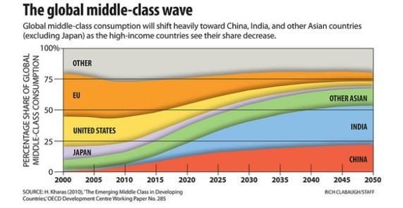

Task 3 – Describe the patterns shown in the graph above. Make reference to rates for countries / regions in 2000 and in 2050.

