IBDP Geography - Atmospheric Feedbacks - Albedo
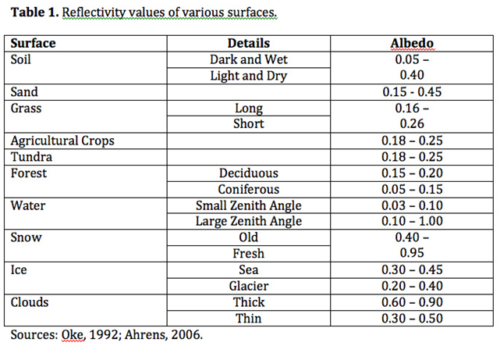

Task 1 – Define Albedo and explain its changes with relation to the surfaces shown in table 1 above

Task 2 – To what extent do seasons alter global albedo levels in the temperate and tundra regions of the northern & southern hemisphere?

Task 3 – Explain what positive feedback means and how a decrease in terrestrial ice coverage can cause positive feedback loops to occur.

