IB Geography – Ecological Footprint & Biocapacity
Task 1 - Map | Key Term | Definition | Brief Description of global distribution. Link here.
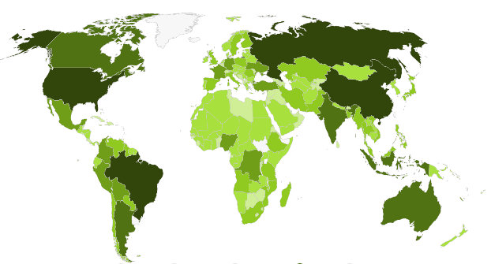 | Biocapacity
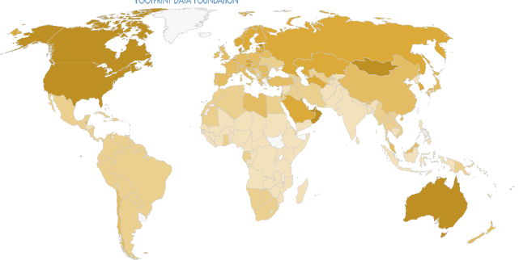 | Ecological Footprint
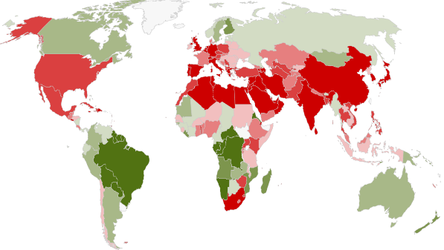 | Ecological Creditor & Debtor
Carbon Footprint

Global Hectare

Task 2 – My Footprint - Take a note of your score as well as a screen shot of your further details and your overshoot day.

How did you do? What features caused your footprint to be bigger or smaller than your peers in the class? Who reaches the overshoot threshold the quickest??

