IB DP Geography – Water Our Most Precious Resource
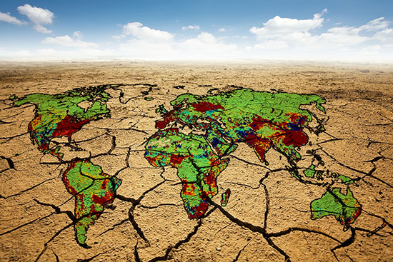

Data | Process / Power / Place / Possibility
97.5% & 2.5%
2/3
0.5%

0.007%

1.2 billion

1914 - 2014

1300 litres

3400 litres

15500 litres
2050

40%

70%
20%
Boston 36%

Singapore 30%

