IB DP Geography – Virtual Water Exports
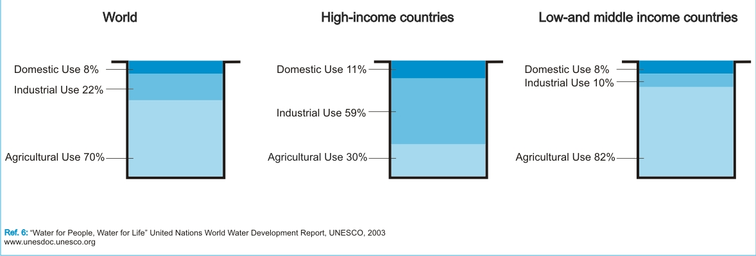
Task 1 - Describe the differences in water use between HICs and L/MICs in the figure above from UNESCO. Try to explain these differences by thinking about levels of development and economic activity.

Task 2i – Using the link on the website, take notes on the four main sources that create demand, namely agriculture, production of energy, industrial uses and human consumption.

Task 2ii – Take notes on the likely impacts of climate change on future water supplies and vulnerable populations.
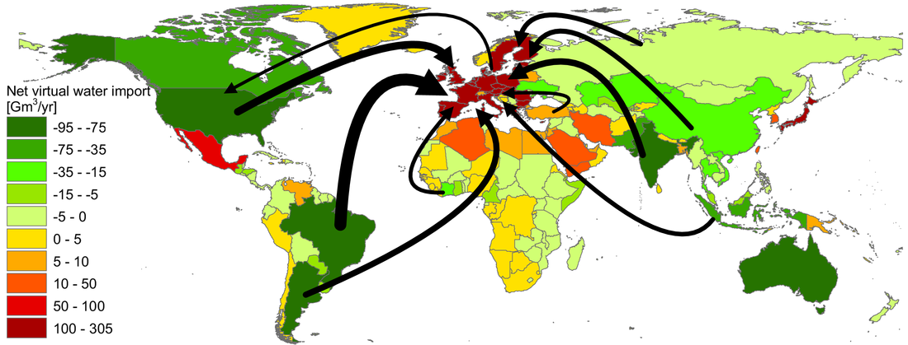
Task 4 - Compare and contrast the imports and exports of virtual water into Europe using the map above

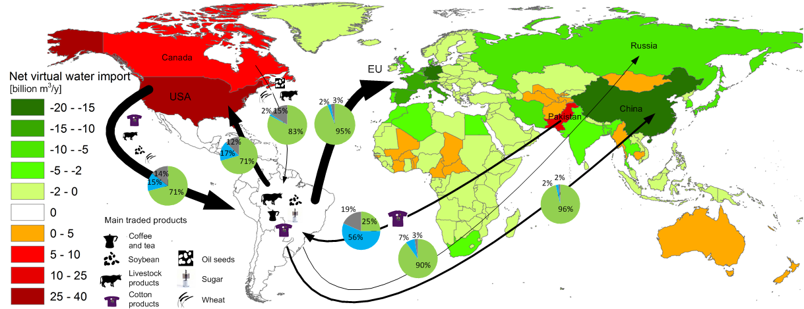

Task 5 - Study the map above carefully, they key and the caption beneath it on the website. The pie chart for each major virtual water flow shows three different colours:

Green = water from vegetation and soil
Blue = water from surface storage and ground water supplies
Grey = water required to clean up pollution.

Describe and explain the flow between Brazil and the EU as well as the flow between Pakistan and Brazil.

