IB Geography Higher Level – MGO’s and Free Trade.
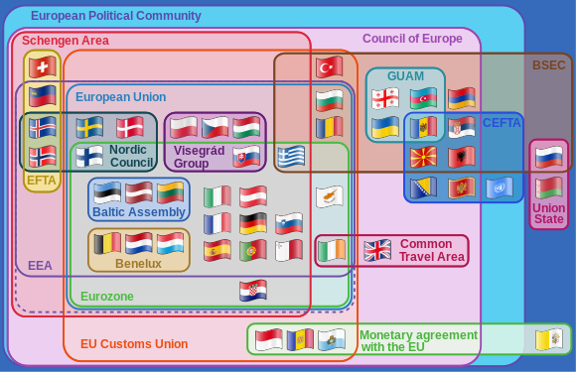

Study this diagram carefully. Define the following:
- Schengen Area

- Council of Europe

- European Free Trade Association

Where are:
- Switzerland -

- France -

- The UK -

Aim 1 - To be able discuss how the EU ensures free trade within its membership.
In less than 50 words, explain how this can happen. Make references to products and services and the increasing importance of the online trade.

Aim 2 - To be able to discuss the role of one multi-governmental organization such as the European Union (EU).

Notes: How does the European Union impact the flow of goods?

The EU has established a single market across the territory of all its members.
The single market involves the free circulation of goods, capital, people and services within the EU.
Companies can sell their products anywhere in the member states and consumers can buy where they want with no financial penalty.
No customs are levied on goods traveling within the EU customs union and (unlike a free trade area) members of the customs union impose a common external tariff on all goods entering the union.
Once goods have been admitted into the market they cannot be subjected to customs duties, discriminatory taxes or import quotas, as they travel internally.
The EU is working to improve cross-border infrastructure within the EU, for example through the Trans-European Networks. Projects include the Channel Tunnel, LGV Est, the Fréjus Rail Tunnel, the Öresund Bridge, the Brenner Base Tunnel and the Strait of Messina Bridge.

Notes: How does the European Union impact the flow of capital?

Currencies and capital can flow freely between the member states and European citizens can use financial services in any member state.
Free movement of capital is intended to permit movement of investments such as property purchases and buying of shares between countries.
Free movement of capital is an essential condition for the proper functioning of the Single Market. It enables a better allocation of resources within the EU, facilitates trade across borders, favours workers mobility, and makes it easier for businesses to raise the money they need to start and grow.

Notes: How does the European Union impact the flow of labour?

Citizens of the EU member states can live and work in any other country and their professional qualifications should be recognised.
With the lifting of most internal border controls, EU citizen can move as freely around Europe as we can within a Member State.
The Schengen Area comprises the territories of twenty-five European countries that have implemented the Schengen Agreement.
Implementing the Schengen rules involves eliminating border controls with other Schengen members while simultaneously strengthening border controls with non-member states.
Before Brexit, the UK declined to join Schengen Convention elements related to passport control, one argument being that, for an island, frontier controls are a better and less intrusive way to prevent illegal immigration than other measures, such as identity cards, residence permits, and registration with the police, which are appropriate for countries with "extensive and permeable land borders".

Explain the functioning of a named multi-governmental organization and its ability to promote free trade between its members. [10 Marks]
__________________________________________________________________________________________________________________________________________________________________________________________________________________________________________________________________________________________________________________________________________________________________________________________________________________________________________________________________________________________________________________________________________________________________________________________________________________________________________________________________________________________________________________________________________________________________________________________________________________________________________________________________________________________________________________________________________________________________________________________________________________________________________________________________________________________________________________________________________________________________________________________________________________________________________________________________________________________________________________________________________________________________________________________________________________________________________________________________________________________________________________________________________________________________________________________________________________________________________________________________________________________________________________________________________________________________________________________________________________________________________________________________________________________________________________________________________________________________________

