IB DP Geography – Honey, I Shrunk The World!
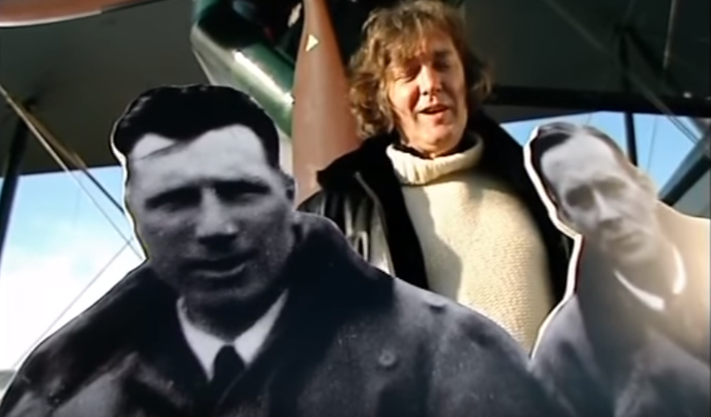
The Plane | The Motor Car | The Television Camera

Which factor do you think has been the most influential in shrinking our planet?

