IB DP Geography – Patterns & Trends in Communication Infrastructure
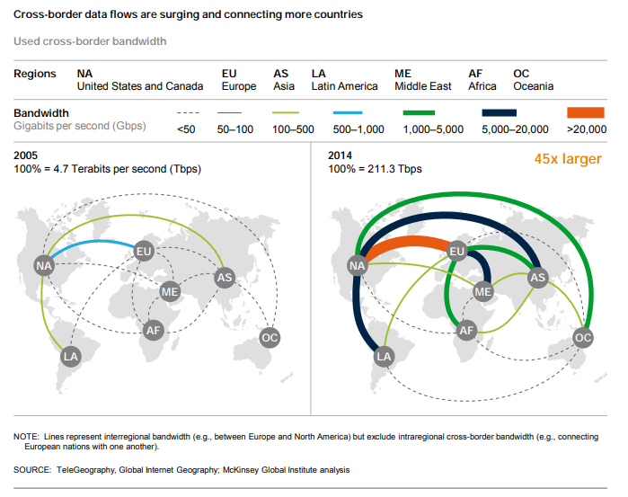
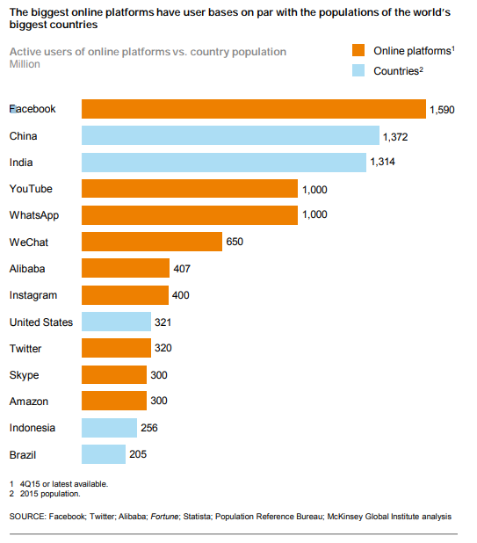
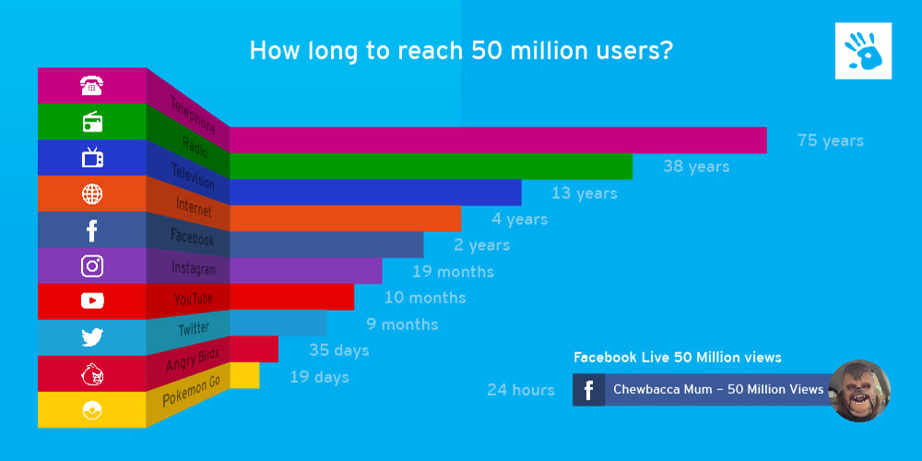

Starter: Comment on the trends shown in the charts above. Write a 50 word summary to describe the growth in global connectivity as well as the rise of social media and reaching the 50 million user mark.

Task 1 – Study the six charts carefully on ibgeographypods. Collect the key data as set out below.
 | France |  | Brazil |  | Ethiopia
 | 2001 | Most recent | 2001 | Most recent | 2001 | Most recent
Fixed Telephone Subscriptions / 100 people.
Mobile Cellular Subscriptions / 100 people
Individuals using internet % of population
Task 2 – Compare the quantity and quality of communication technology between the three countries above.
Task 3 - What processes play a part in how technologically advanced these places are? (synthesis)

