IB Geography – Having all your resource ‘eggs’ in one dangerous basket!
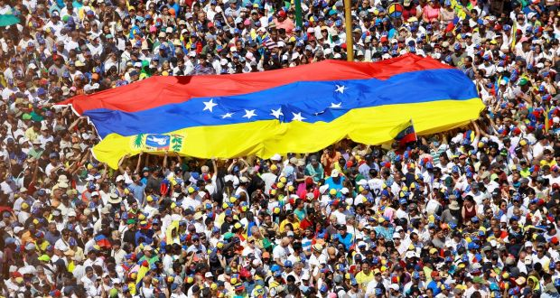
Watch the VOX video and take basic notes on how the crisis in Venezuela has escalated in recent years.

The background:
- Oil dependence. Oil sales make up 99 percent of export earnings and roughly one-quarter of gross domestic product (GDP).

- Falling production. Starved of adequate investment and maintenance, oil output has declined to its lowest level in decades.

- Spiralling economy. GDP shrank by roughly two-thirds [PDF] between 2014 and 2019, and experts forecast that, with plummeting demand for oil amid the coronavirus pandemic, it would decline by roughly another 30 percent in 2020.

- Soaring debt. Venezuela has an estimated debt burden of $150 billion or higher, more than double the estimated size of its economy.

- Hyperinflation. Annual inflation is running at 6,500 percent.

- Growing autocracy. President Nicolas Maduro and his allies have violated basic tenets of democracy to maintain power.

Take further notes from this article here: https://www.cfr.org/backgrounder/venezuela-crisis

