IB Geography – Unseasonal Potatoes – A globalized supply chain
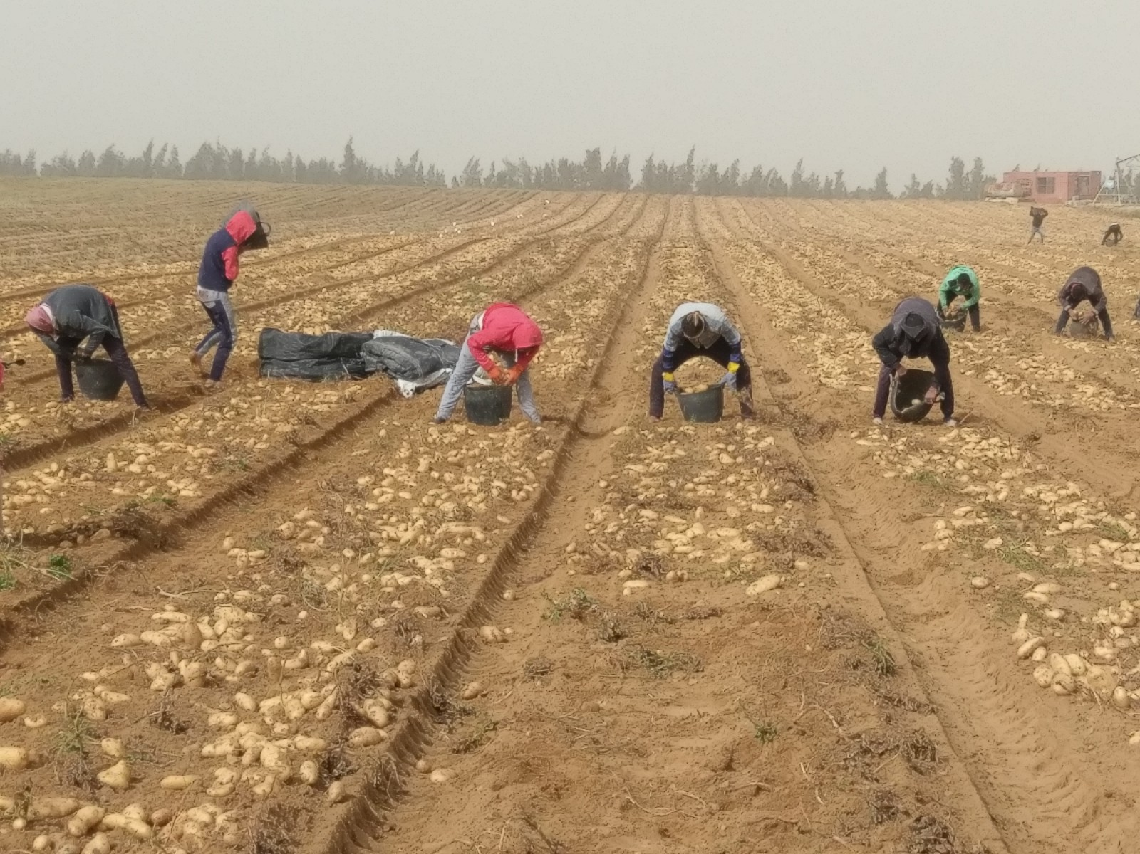
Watch the two videos embedded on geographypods and complete the note taking below.

What are the challenges in growing the crop in a desert environment?

Outline the reasons why potatoes are grown in Egypt.

Describe how irrigation is carried out on these farms.

Outline the role of Ireland and Scotland in the production of these potatoes.

How are these potatoes transported to their final destination market?

Draw flow arrows on the map to show the interactions between different countries outlined in the videos.

