Part 4– Global Superpowers – Cold War to Trade War
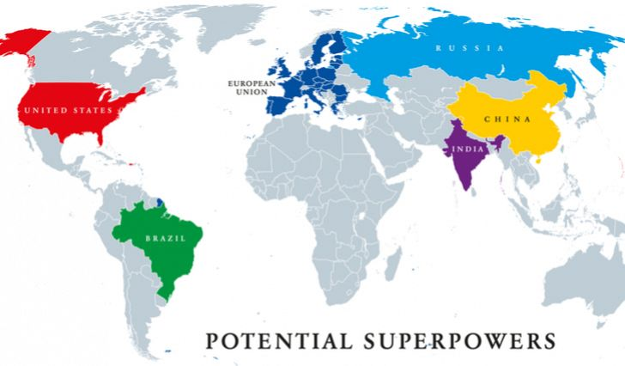

Watch | Read | Listen
www.youtube.com/watch?v=mvt_4DqPjvc | http://www.bbc.com/travel/story/20200322-five-superpowers-ruling-the-world-in-2050 | https://www.bbc.co.uk/programmes/articles/JG9nqGfQnm3WnXHyvV6tD3/seven-ways-china-is-shaping-up-to-become-the-worlds-number-one-superpower - listen to all 7 x 1-minute podcasts (7 minutes in total!)

Who were the two ‘original superpowers’? What caused the halt in the competition between the two superpowers and how and why might the power base be changing in the future?

Music time – Study the four music videos carefully and pick out the links to particular superpowers and events that shaped the time when the songs were written.

Artist & Song | YouTube Video Link | Superpowers involved | Key lyrics that show link to superpower conflict.
Randy Newman – Political Science  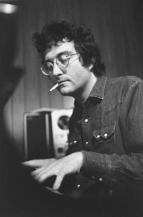  **If you’ve ever watched Toy Story, you will recognize his voice  . | Video Link
The Scorpions – Wind of Change  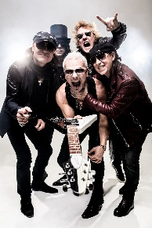 | Video Link
Bruce Springsteen – Born in the USA  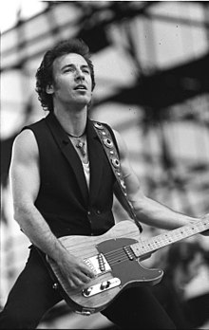 | Video link

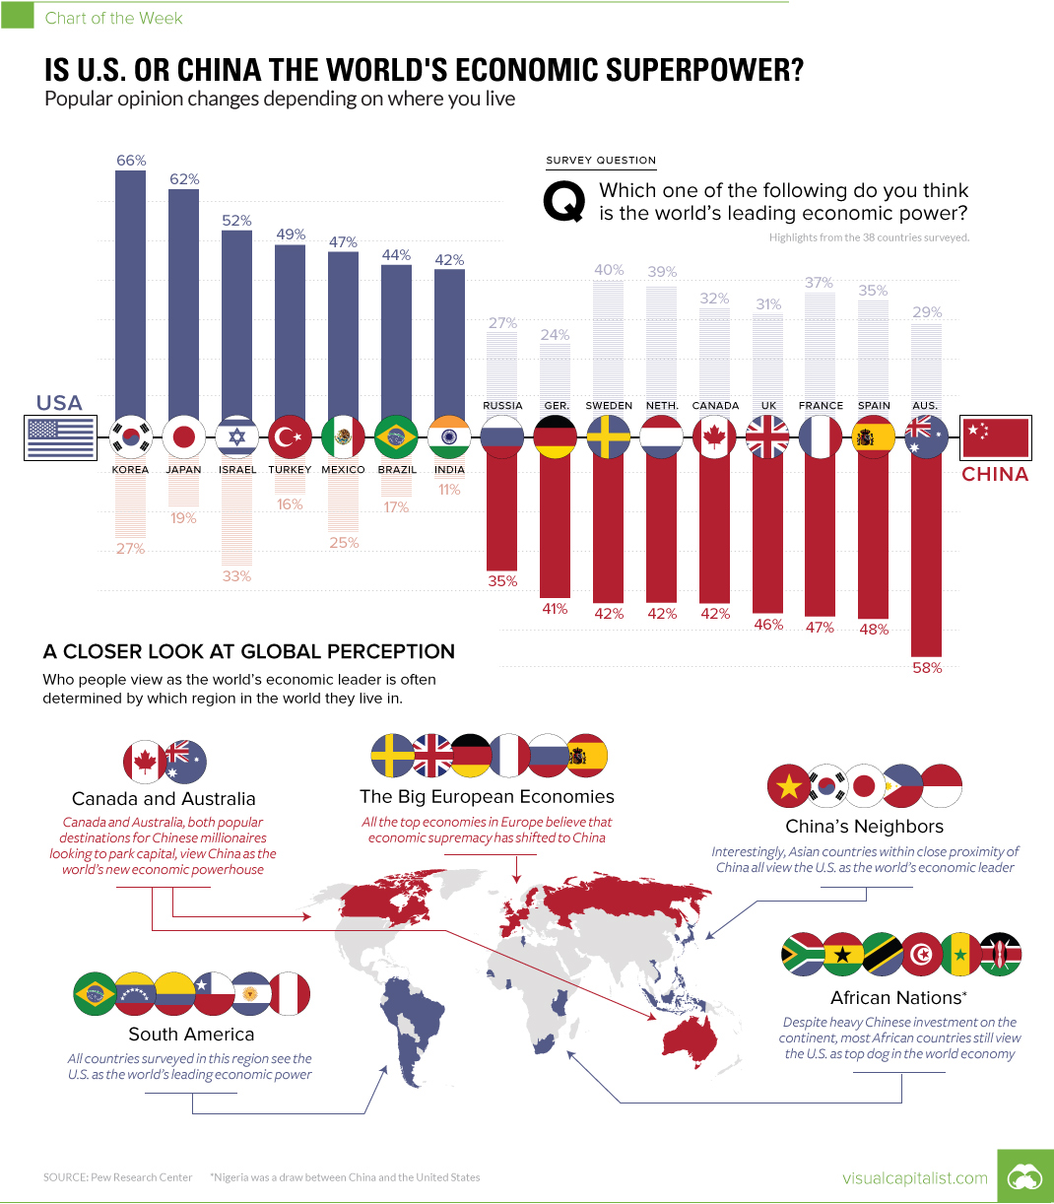

Study the infographic above. Is there a correlation between spatial proximity to China / USA and the belief that they are the most powerful? Give two pieces of data to back up your answer.

Collaboration Time - Key Questions for Investigation

Working with a partner, each choose a different task (see below) and create a micro presentation to give to them with your response.

You could also work in groups of three.
- Question: Why do superpowers exist?

- Question: Will China be the most dominant economy in the world by 2050?

- Creative Task: Survey a collection of everyday items (clothing, electronics, DVDs, music, food etc.) in your household. Photograph the items that are linked to / from the USA and those that are linked to / from China. Where is the power balance in your house?

Extension – Improve Your Knowledge - Cold War to Trade War
Read this article - https://www.bbc.com/news/business-45899310

