Part 6 – Disruptive Technologies
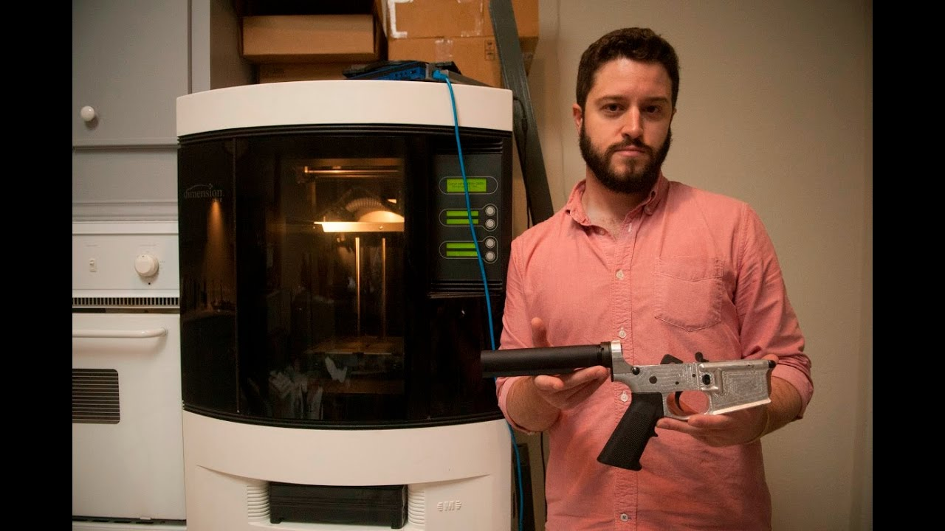

Watch
https://www.youtube.com/watch?v=DconsfGsXyA

Key notes from the video
Make notes on the video below.

What are the pros and cons of the disruptive technology possibilities offered by Cody R Wilson including DEFCAD?

Study the following news stories and make a 100 summary to explain why the technology in question could be considered ‘disruptive.
Prisons & Drones | https://www.youtube.com/watch?v=BezZxQF2pRw
100 word summary

Study the following news stories and make a 100 summary to explain why the person in question could be considered reactionary to disruptive technology.
Bug bounty hacker | https://www.youtube.com/watch?v=J4ElhxkLUk8
100 word summary

Collaboration Time - Key Questions for Investigation

Working with a partner, each choose a different task (see below) and create a micro presentation to give to them with your response.

You could also work in groups of three.
- Question: How many examples of disruptive innovation can you name?

- Question: To what extent are disruptive technological innovations a positive influence for humankind?

