Social entrepreneurship & human development
Name of project _______________________
Gender Inequalities Economic Inequalities

Ethnic Inequalities
Political Inequalities

Social Inequalities

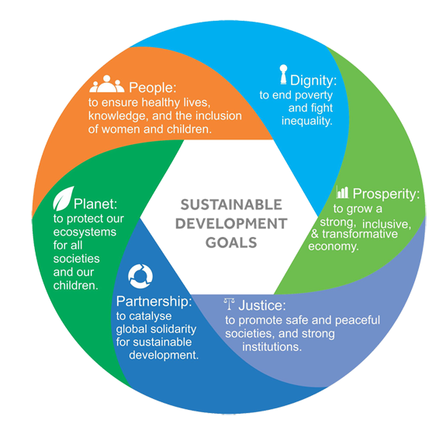

Place (where) | Process (why & what)
Power (who) | Possibility

