IB DP Geography – Climate & Dimming due to volcanic eruptions

Process | Place
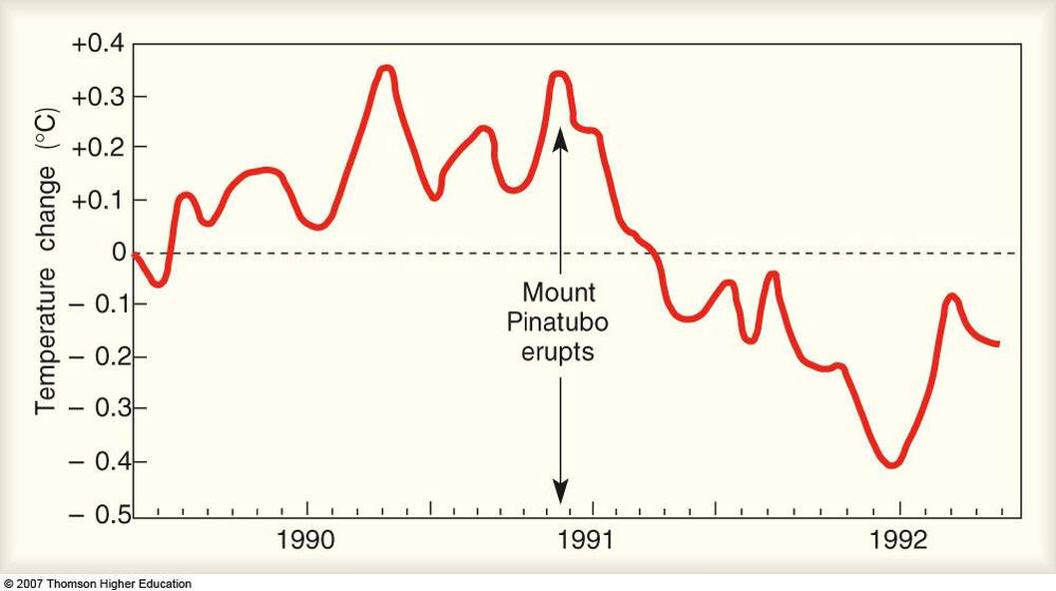

Power | Possibility

Perspectives….

